1. Input the age of the voter and check whether he is eligible to vote based on the age older than 18 years.

Begin

Numeric age;

Accept age;

If(age>=18)

{

Display “eligible”

}

Else {

Display “Not Eligible”

}

End

2)  Check your Admission possibility to your dream College based on your academic marks.

Pseudocode:

Begin

Numeric marks;

Accept marks;

If(marks>65) {

Display “Eligible for admission”

}

Else {

Display “Not Eligible for admission”

}

End

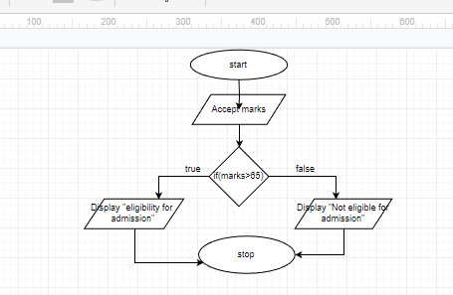

3)Find the sum and average of three numbers.

Begin

Numeric sum, average, n1, n2, n3;

Accept n1,n2,n3;

Sum=n1+n2+n3;

Average=sum/3;

end